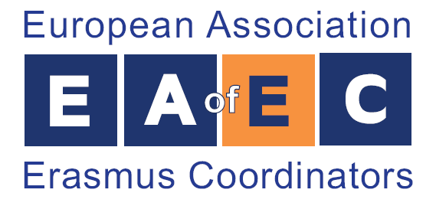

ERASMUS CONGRESS AND EXHIBITION 2014
28 April - 2 May 2014, Nicosia, Cyprus
www.eracon.info, www.eaec.eu.com, eracon@ucy.ac.cy, info@eaec.eu.com

NOMINATION FORM
“ERASMUS ACADEMIC MINISTERS 2014”

A. University/Institution
University/Institution Name
(in English)
University/Institution Name
(in national language)
ERASMUS Code
Initiation year of ERASMUS
Programme in your country
University/Institution Address
(number, street, postal code, city)
Country

B. Nomination of ERASMUS Academic Coordinator
Surname/Given name
(in English)
Gender
(Male or Female)
Nationality
Telephone (start with country code)
Email Address
Academic discipline
Number of years as an ERASMUS Academic Coordinator

C. Rector’s Contact Details
Name Surname
(in English)
Telephone
Email Address
(signature)  ERASMUS Academic Coordinator  Date: |  | (signature and stamp)  Rector  Date:
Please send this form to the European Association of ERASMUS Coordinators, EAEC by email at info@eaec.eu.com

Deadline: 4 April 2014

